PrewittVision - Edge Detection with the Prewitt Operator: Implementation and Analysis

By Mitchell Carroll and Matthew To

PrewittVision is an efficient image processing application that leverages parallel programming techniques using CUDA to perform accelerated edge detection on .png images. By implementing the Prewitt Operator on blocks of pixels in parallel, PrewittVision delivers high-performance gradient image generation, highlighting detected edges. Edge detection is a type of algorithm used to determine the boundaries of objects within an image, or more technically, defined by sharp changes in brightness. The

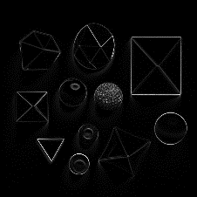

Figure : An image with a bunch of shapes (left), image after applying edge detection with the Prewitt operator

This algorithm was selected as it can be implemented sequentially, and be accelerated by use of multiple threads of a CPU or GPU.

Data workflow:

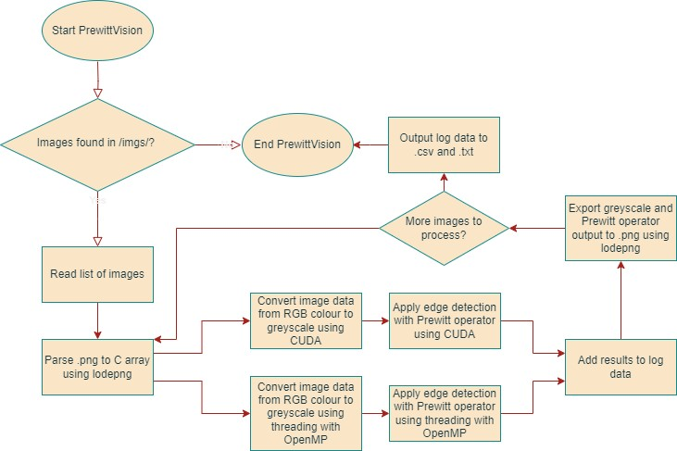

Figure : Workflow of PrewittVision

Prewitt Kernel

|  |  |  |  |
| --- | --- | --- | --- |
| File Name | Original Image | Greyscale Image Output | Prewitt Operator Output |
| objects |  |  |  |
| objects2 |  |  |  |
| computer_chip |  |  |  |
| fruit_basket |  |  |  |
| husky_cardinal |  |  |  |
| network |  |  |  |
| rooster |  |  |  |

Analysis of Algorithm

|  |  |  |  |  |  |  |  |  |
| --- | --- | --- | --- | --- | --- | --- | --- | --- |
| **Greyscale** | **CPU/OpenMP by threads** | | | | **CUDA by block size** | | | |
| *File Name* | *1* | *2* | *6* | *16* | *4* | *8* | *16* | *32* |
| objects.png | 4.304 | 2.544 | 1.206 | 5.632 | 0.137 | 0.044 | 0.03 | 0.045 |
| objects2.png | 3.623 | 2.053 | 1.266 | 3.77 | 0.197 | 0.034 | 0.042 | 0.044 |
| computer_chip.png | 3.254 | 2.118 | 1.267 | 9.108 | 0.124 | 0.2 | 0.4 | 0.025 |
| fruit_basket.png | 3.674 | 2.145 | 1.19 | 3.069 | 0.145 | 0.031 | 0.05 | 0.262 |
| husky_cardinal.png | 3.586 | 2.818 | 2.488 | 6.157 | 0.135 | 0.039 | 0.045 | 0.136 |
| network.png | 5.215 | 2.868 | 1.144 | 3.743 | 0.137 | 0.044 | 0.03 | 0.045 |
| rooster.png | 3.949 | 3.087 | 1.006 | 0.842 | 0.15 | 0.052 | 0.028 | 0.032 |
| Average | 3.944 | 2.519 | 1.367 | 4.617 | 0.146 | 0.063 | 0.089 | 0.084 |
| Parallel Overhead |  | 1.094 | 4.257 | 69.933 |  |  |  |  |
| Parallel Speedup |  | 1.566 | 2.885 | 0.854 | 26.932 | 62.173 | 44.168 | 46.868 |
| Parallel Efficiency |  | 0.783 | 0.481 | 0.053 |  |  |  |  |

|  |  |  |  |  |  |  |  |  |
| --- | --- | --- | --- | --- | --- | --- | --- | --- |
| **Prewitt Operator** | **CPU/OpenMP by threads** | | | | **CUDA by block size** | | | |
| *File Name* | *1* | *2* | *6* | *16* | *4* | *8* | *16* | *32* |
| objects.png | 29.667 | 15.182 | 5.119 | 3.403 | 0.074 | 0.052 | 0.05 | 0.115 |
| objects2.png | 29.946 | 16.172 | 5.056 | 3.454 | 0.081 | 0.054 | 0.052 | 0.175 |
| computer_chip.png | 34.52 | 17.524 | 5.983 | 3.521 | 0.134 | 0.047 | 0.049 | 0.159 |
| fruit_basket.png | 38.477 | 19.135 | 6.635 | 4.334 | 0.069 | 0.035 | 0.043 | 0.106 |
| husky_cardinal.png | 29.981 | 15.432 | 5.11 | 3.447 | 0.077 | 0.054 | 0.05 | 0.051 |
| network.png | 33.809 | 17.41 | 6.131 | 3.352 | 0.083 | 0.048 | 0.043 | 0.048 |
| rooster.png | 29.785 | 14.931 | 5.117 | 3.417 | 0.077 | 0.051 | 0.157 | 0.055 |
| Average | 32.312 | 16.541 | 5.593 | 3.561 | 0.085 | 0.049 | 0.063 | 0.101 |
| Parallel Overhead |  | 0.770 | 1.246 | 24.666 |  |  |  |  |
| Parallel Speedup |  | 1.953 | 5.777 | 9.074 | 380.143 | 663.299 | 509.426 | 319.020 |
| Parallel Efficiency |  | 0.977 | 0.963 | 0.567 |  |  |  |  |